W1REX's Favorite Kit Building Tools
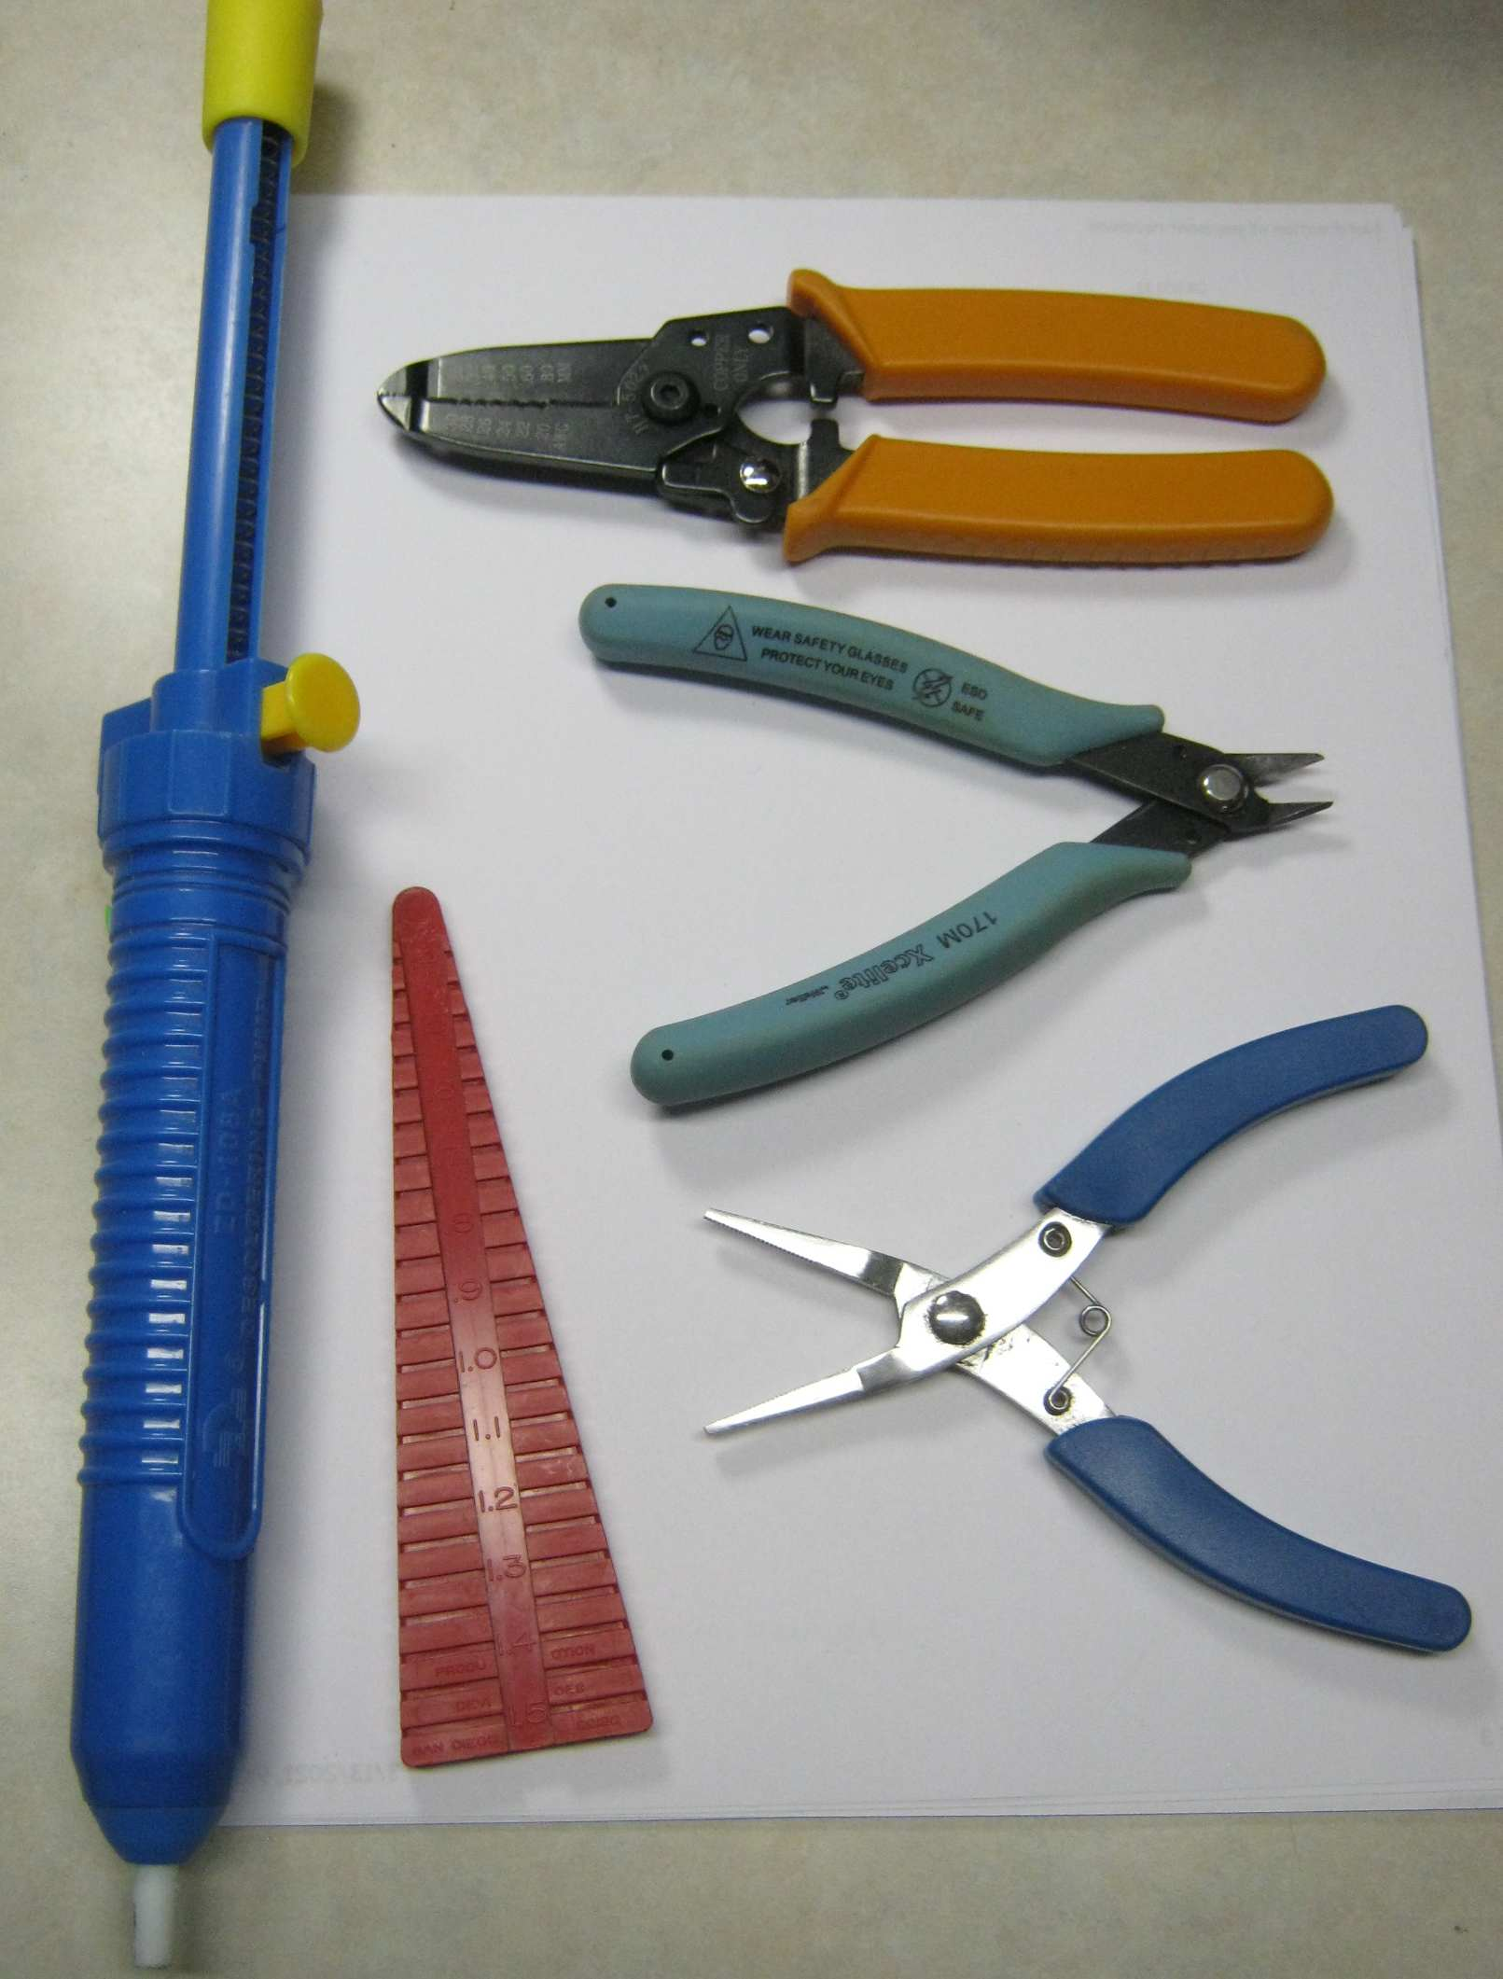
From Jameco Electronics: https://www.jameco.com/
Wire Strippers: 159291 @ 9.95
Flush Cutters: 146712 @ 9.95
Long Nose Pliers: 35474 @ 5.39
Lead Former: 106884 @ 4.95
Solder Sucker: 1942139 @ 8.95
Adjustment Tool: 153315 @ 2.25 (not pictured)

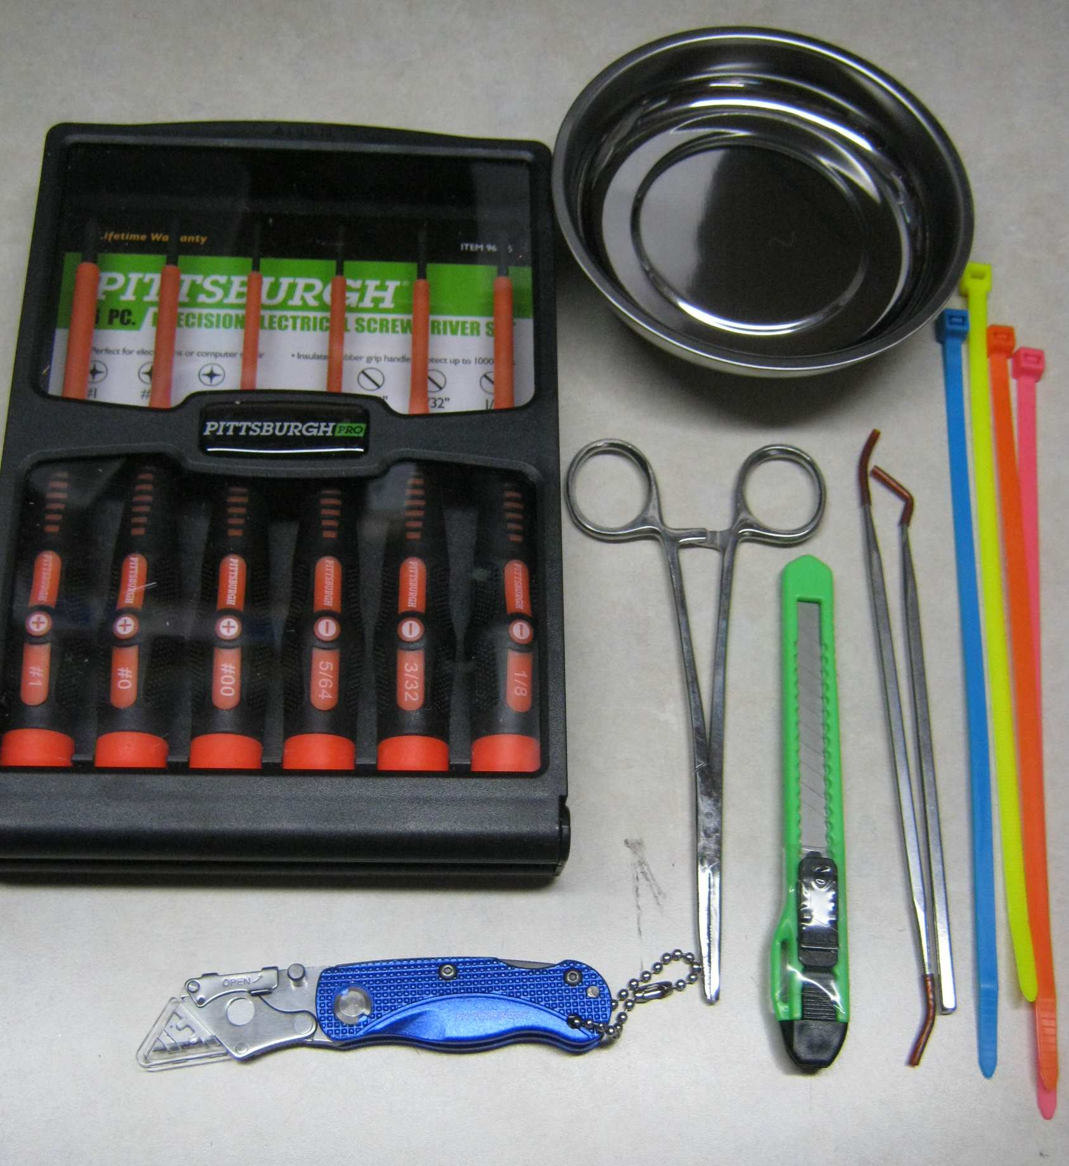
From Harbor Freight: 'in a major city near you'
Magnetic Pasts Holder: 90566 @ 2.99
8” Zip Ties: 98727 @ 2.99
Stainless Hook & Picks: 93514 @ 4.99
Pocket Box Cutter: 60828 @ .59
Locking Clamp: 99930 @ 3.99
Mini Utility Knife: 93859 @ 9.99 (½ of 2 pk)
Precision Screwdrivers: 96075 @ 7.99

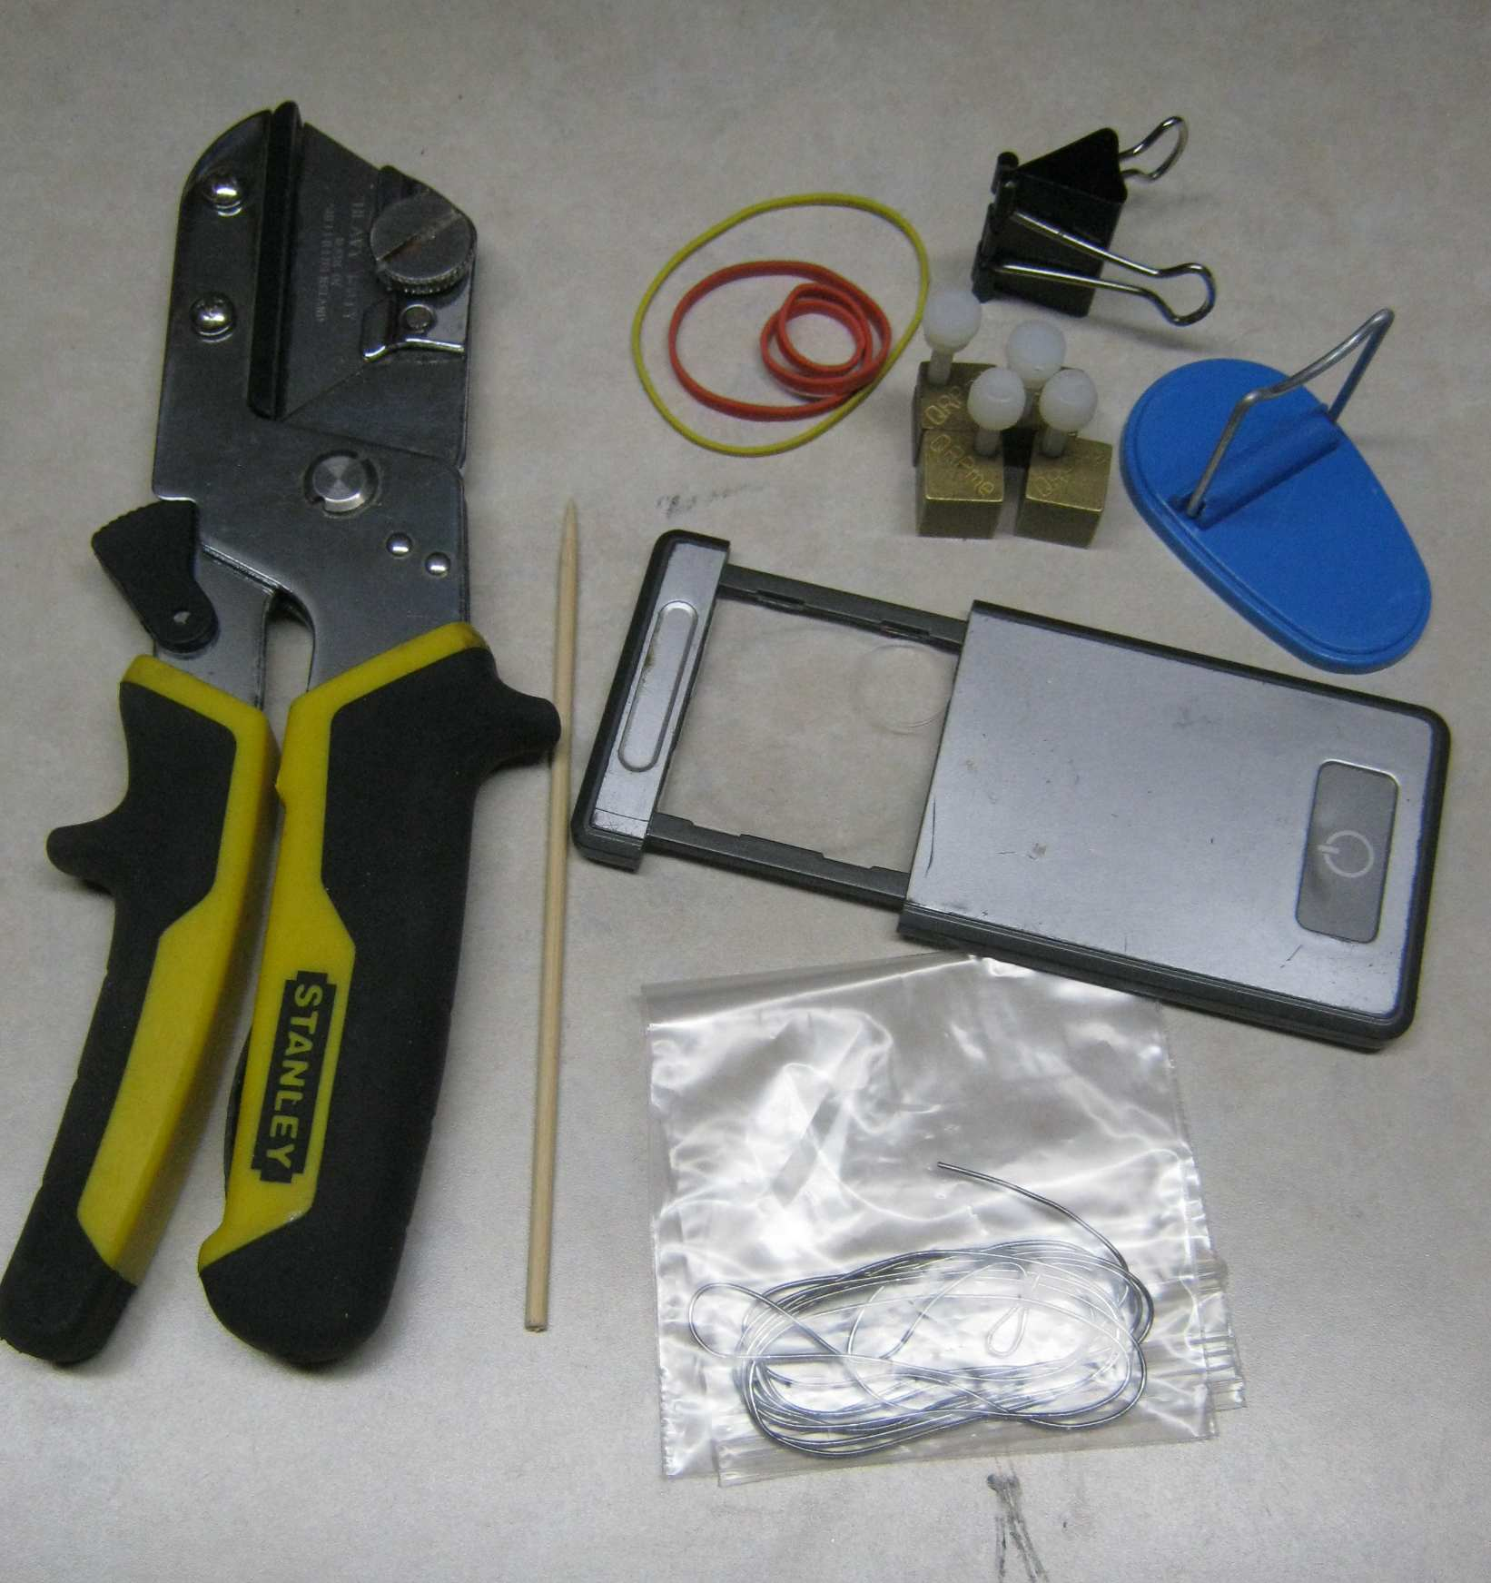
Miscellaneous Sources:
rubber bands, binder clip from Sam's Club
collapsible soldering iron holder from ?? (possibly Radio Shack)
'A Brass Set' circuit board holders from QRPme
LED lighted dual magnification magnifier from ??
Solder: Kester44 .031 1 lb. spool but un-spooled and sealed in bag
kebab skewer from my local grocery store
Guillotine Cutters from my local hardware store.

I love my guillotine cutter but they has been discontinued by many sources. Stanley, Home Depot, Lowe's and Tractor Supply have all carried it in one form or another but they ALL eventually discontinued it probably due to the advice from their liability lawyers. They are very sharp and can potentially cut your finger clean off if you are not careful as they are wicked sharp....but they are also wicked handy! There all other versions of these pliers with longer specialty blades but I like the ones that use an ordinary utility knife blade.

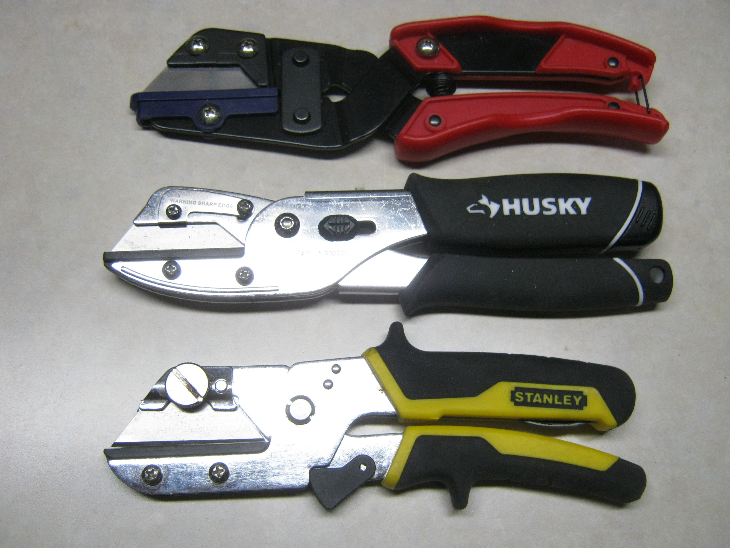
I found one recently on Amazon:
https://www.amazon.com/Hangzhou-Indust-139028-Utility-Cutter/dp/B00827OJ5K/ref=sr_1_10?crid=GMHCTQNG4T7L&dchild=1&keywords=utility+cutter+pliers&qid=1616290289&sprefix=utility+cutter%2Caps%2C303&sr=8-10

THE most important item for kit building....
A GOOD soldering iron or soldering station!
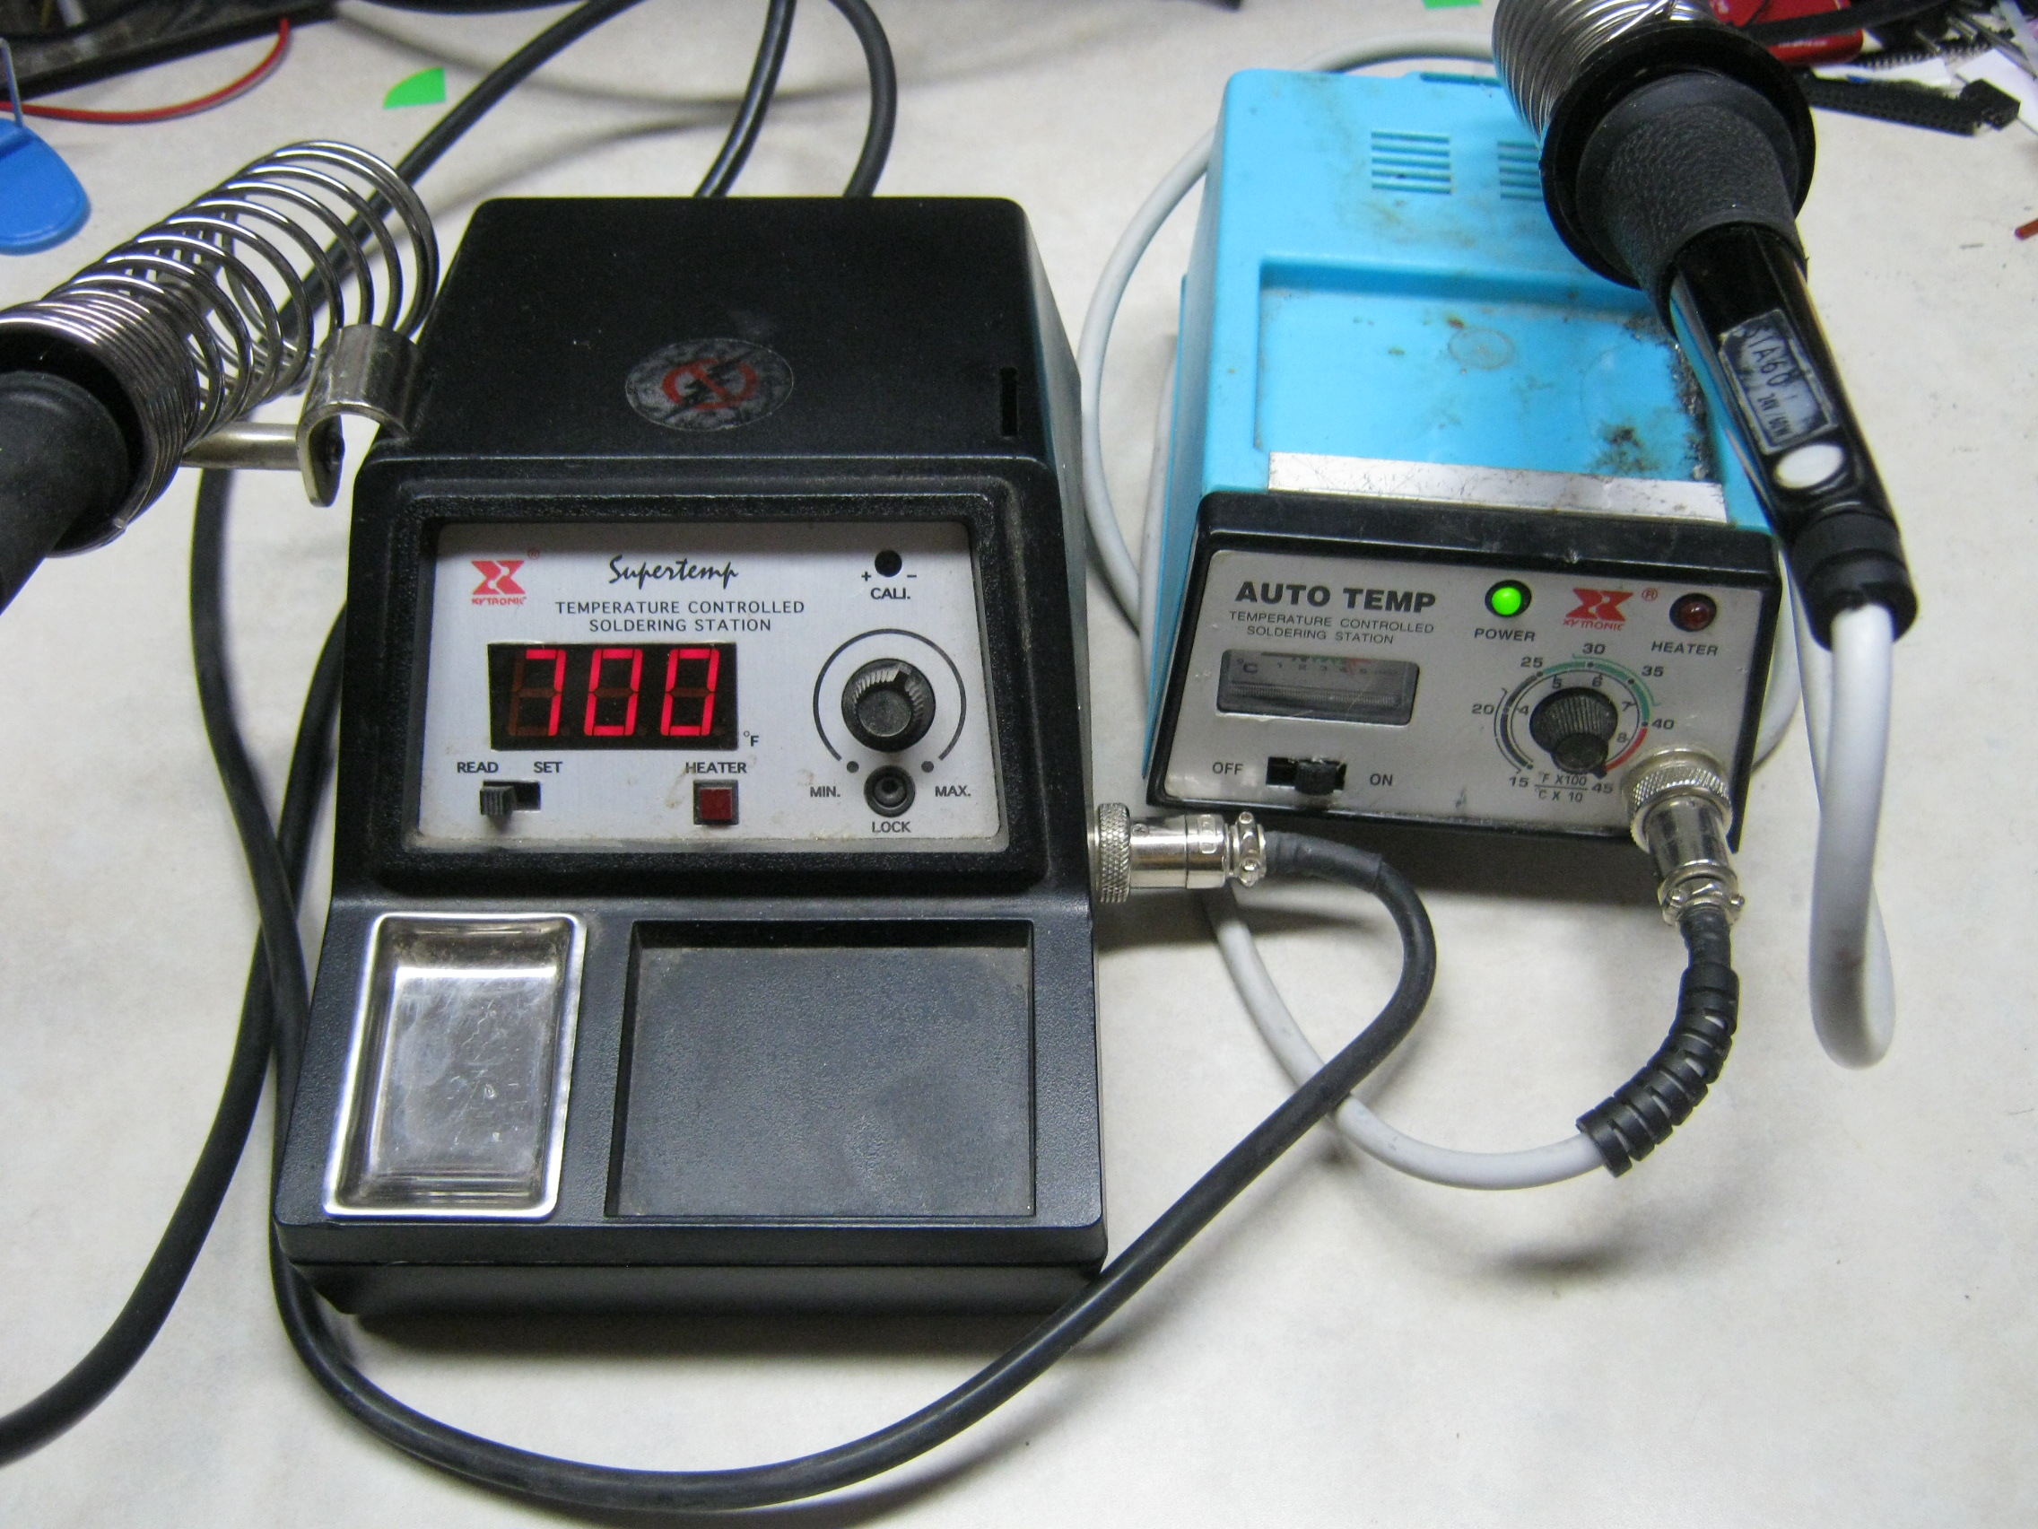
These are 2 of the many Xytronic soldering stations I have in my shop. I bought these from Jameco Electronics over 30 years ago and they have served me well. As you can see, one has an analog temperature set/display and the other is digital. As far as I am concerned, either one is perfectly acceptable but you probably won't run across many analog displays these days. The most important factor in buying a station is whether it is sold by a dealer who stands behind it and stocks replacement irons and tips. If you want to get a long life from your station purchase, you will need to replace a tip now and then and sometimes you may have to replace the actual iron. I also have a couple of Wellers and a Metcal on my main bench. You should consider buying an affordable station for you hobby needs as it really does help you improve your soldering skills.

Jameco Electronics in Belmont CA has many private label soldering irons and stations (BenchPro) and still carry Xytronic soldering stations and parts. I buy parts for my stations from them.
You can find them here under tools/soldering: https://www.jameco.com/

Another great source of soldering irons and stations is Circuit Specialists in Tempe AZ. Thay have lots of soldering iron and station options. You should be able to find one that fits your personal price point. Find their options under Soldering:
https://www.circuitspecialists.com

Personally, I have both a 60 watt station and a 75 watt station and under typical kit building conditions, BOTH wattages work equally well. If you do a lot of bigger soldering, say soldering copper clad pieces together for making an enclosure, go for the highest wattage that is available that fits your budget. I also have a 250 watt Weller soldering gun and a couple of my dad's humongous heavy duty soldering irons from the 50's in my soldering arsenal. A good soldering station will give you a lifetime of soldering service...but you will need replacement parts eventually. You should try to source your station from a dealer that will be around when you need those parts. Enough said about that. Soldering temperature is another touchy topic. I prescribe to the run a HOT iron and get in and get out fast theory. I run my iron at 700 and try to work fast. Your temperature and speed may vary.... but 2 things are true:
- Don't put too much heat to the part & pad.
- Don't use more solder than necessary to make the connection.
It is hard to acquire decent soldering skills with a crappy soldering iron.....
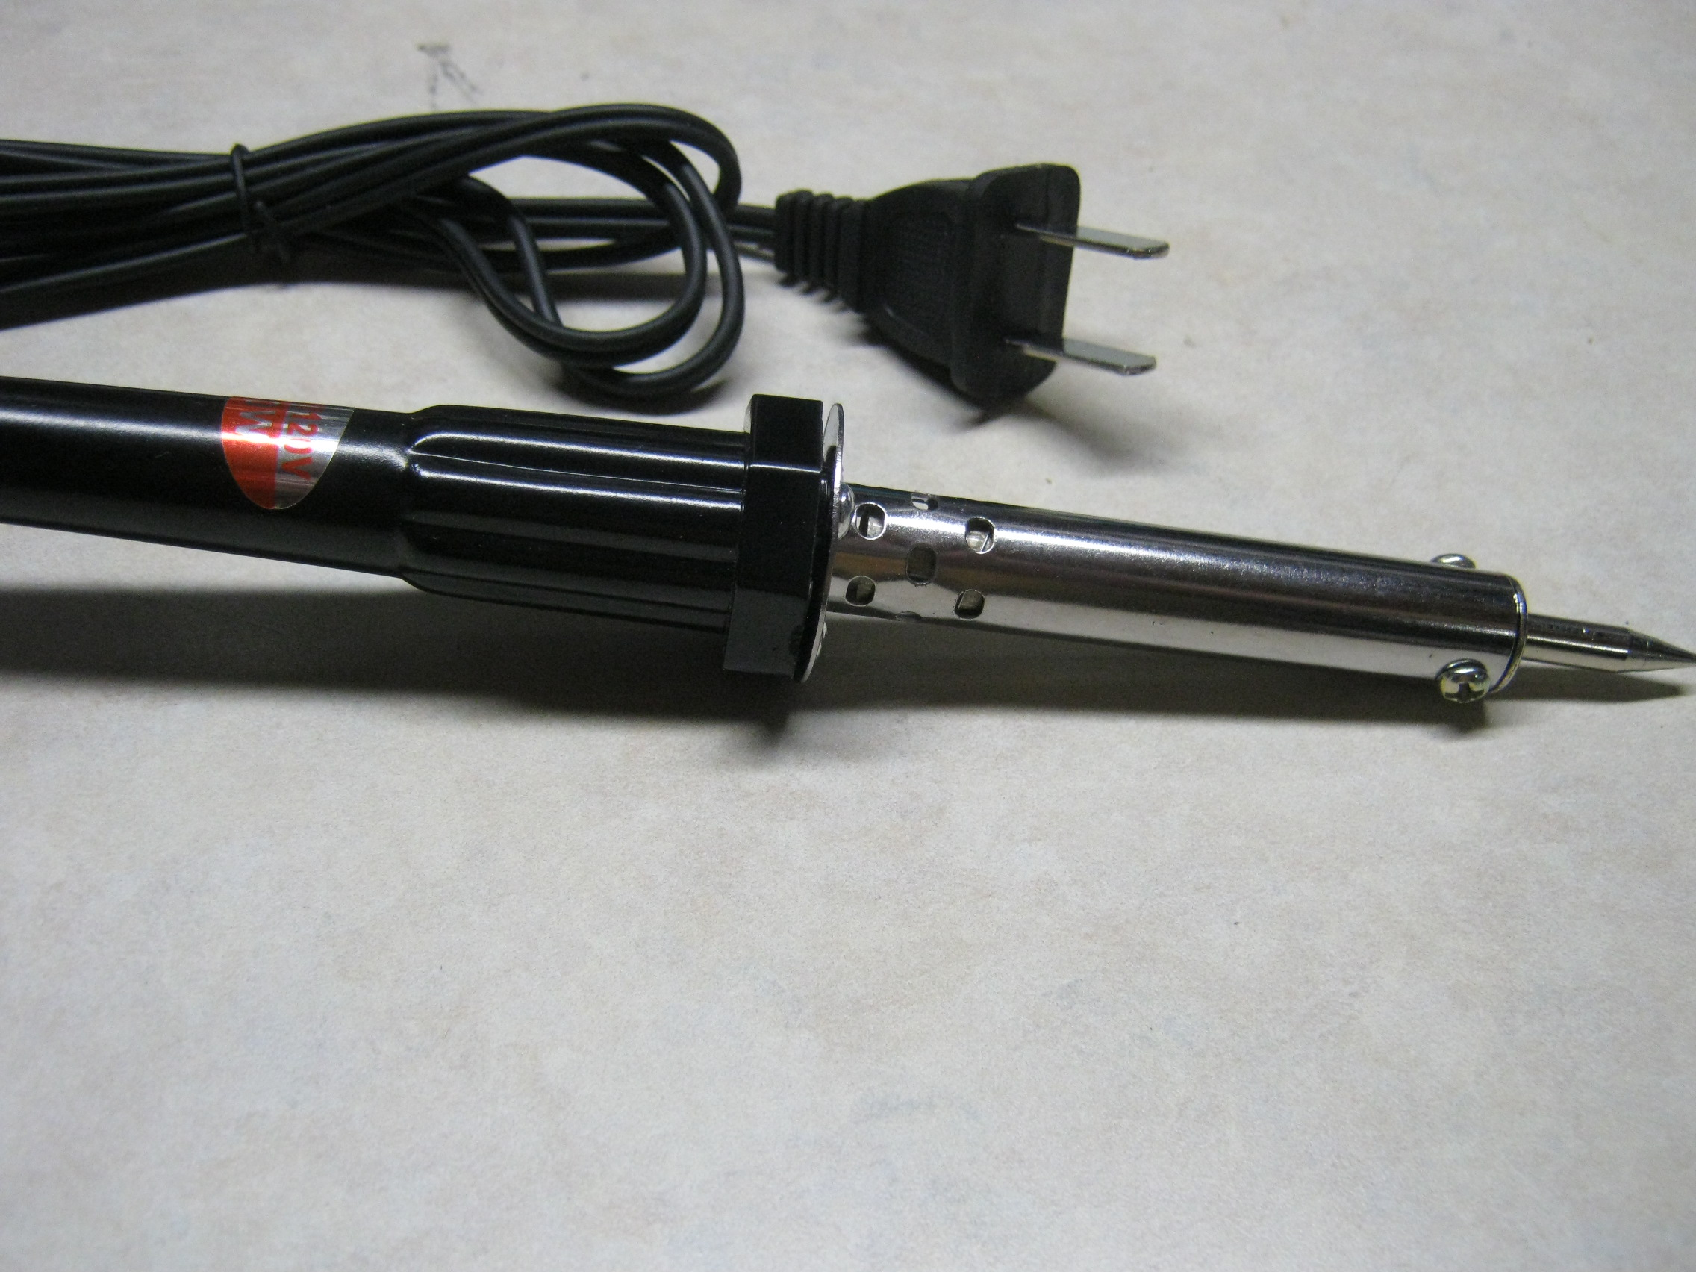
Here is a typical crappy iron that you see selling for cheap money at hamfests or even in big box stores....

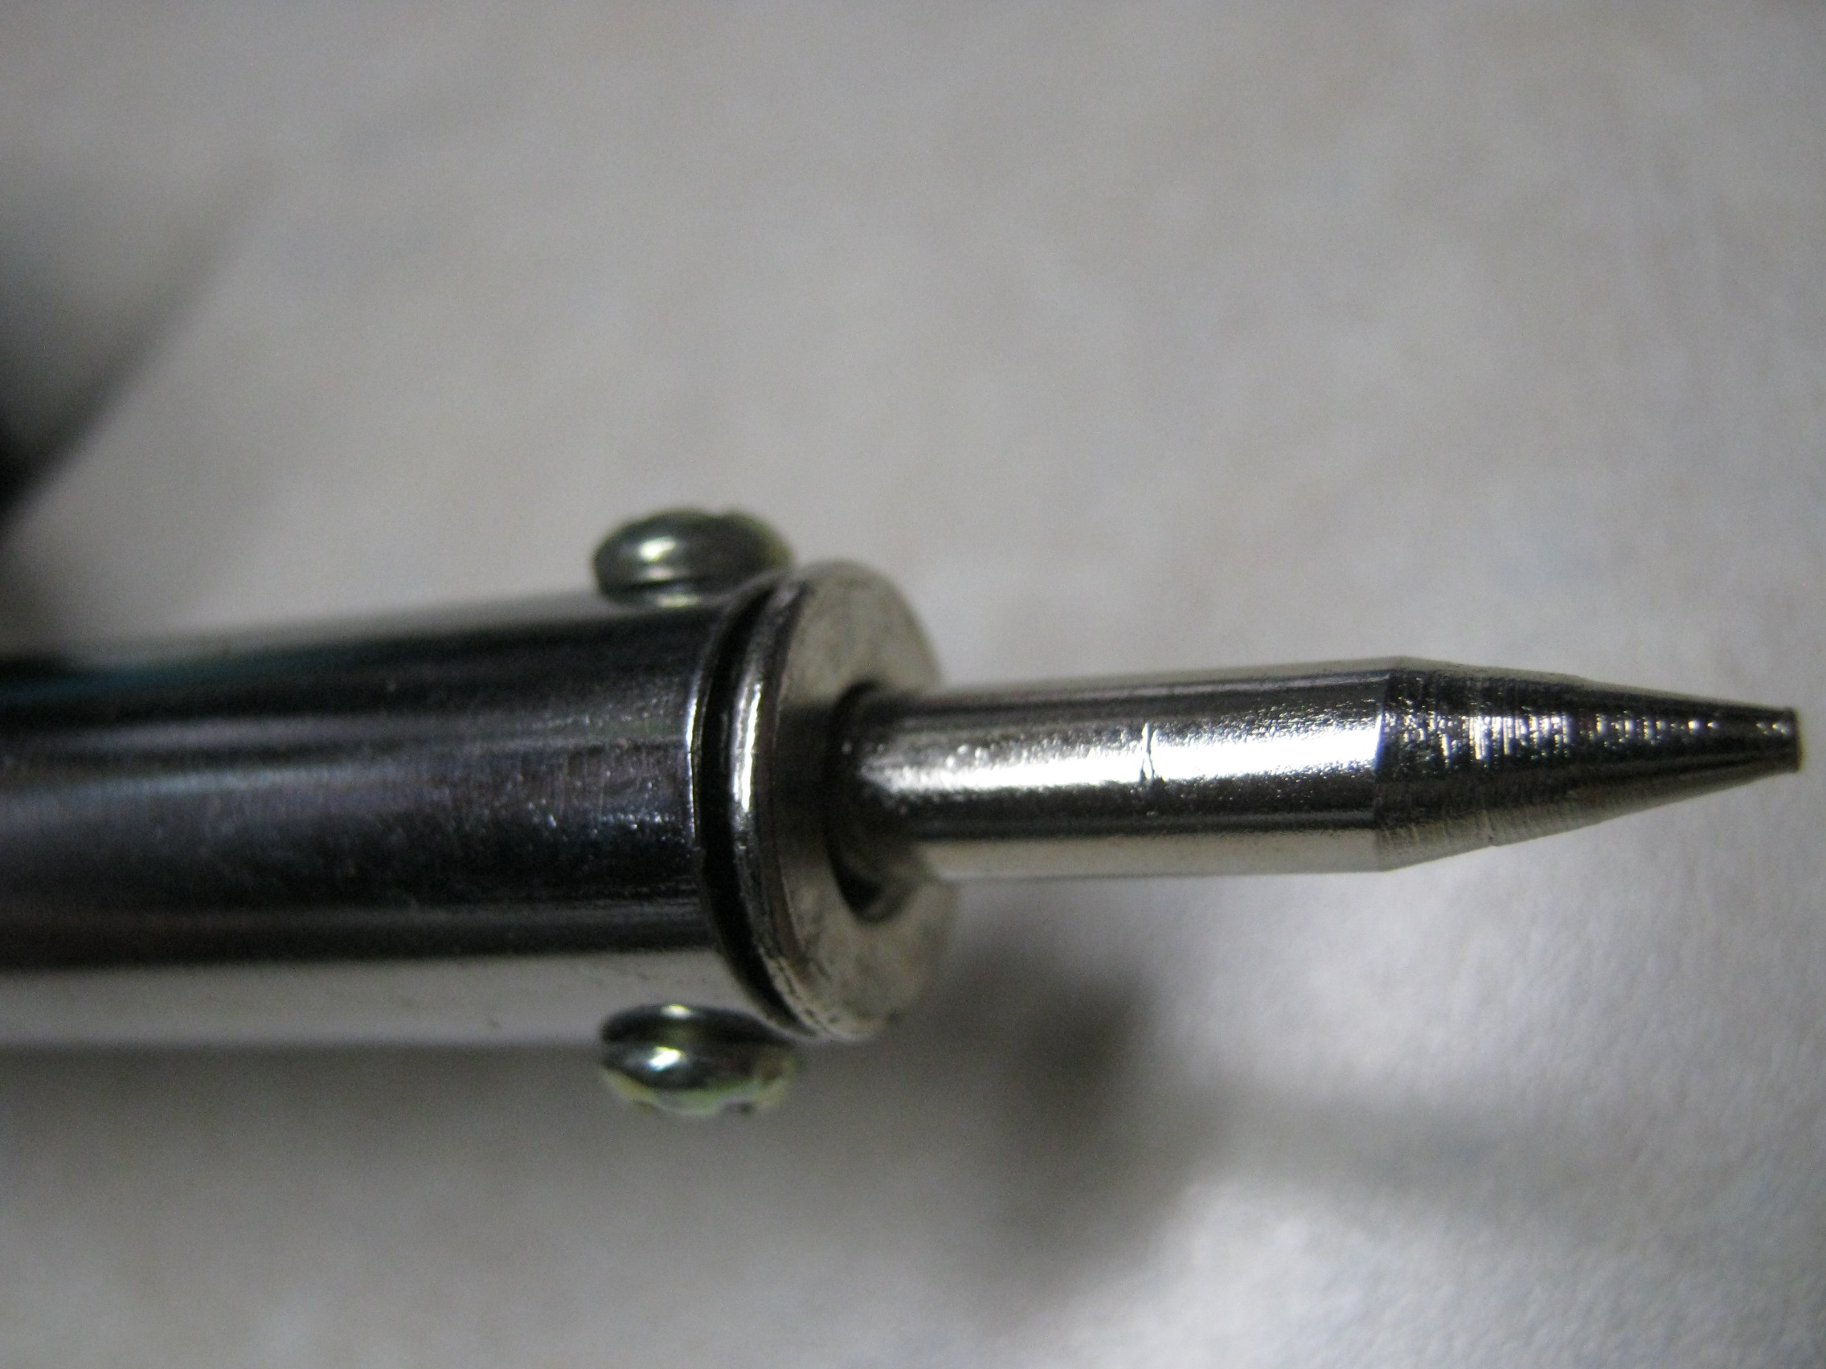
Here is a close-up of the typical crappy tip. They
are replaceable but the tip
itself is really bad. The
plating is poor and the tip
is very hard to keep tinned.

Stay away from this type of
iron or use it for either
wood burning or plastic
melting chores.
NEVER use you good iron or station for wood burning or plastic melting. Residue from those projects stays on you tip and fouls it for soldering!
A SUPER portable butane iron.
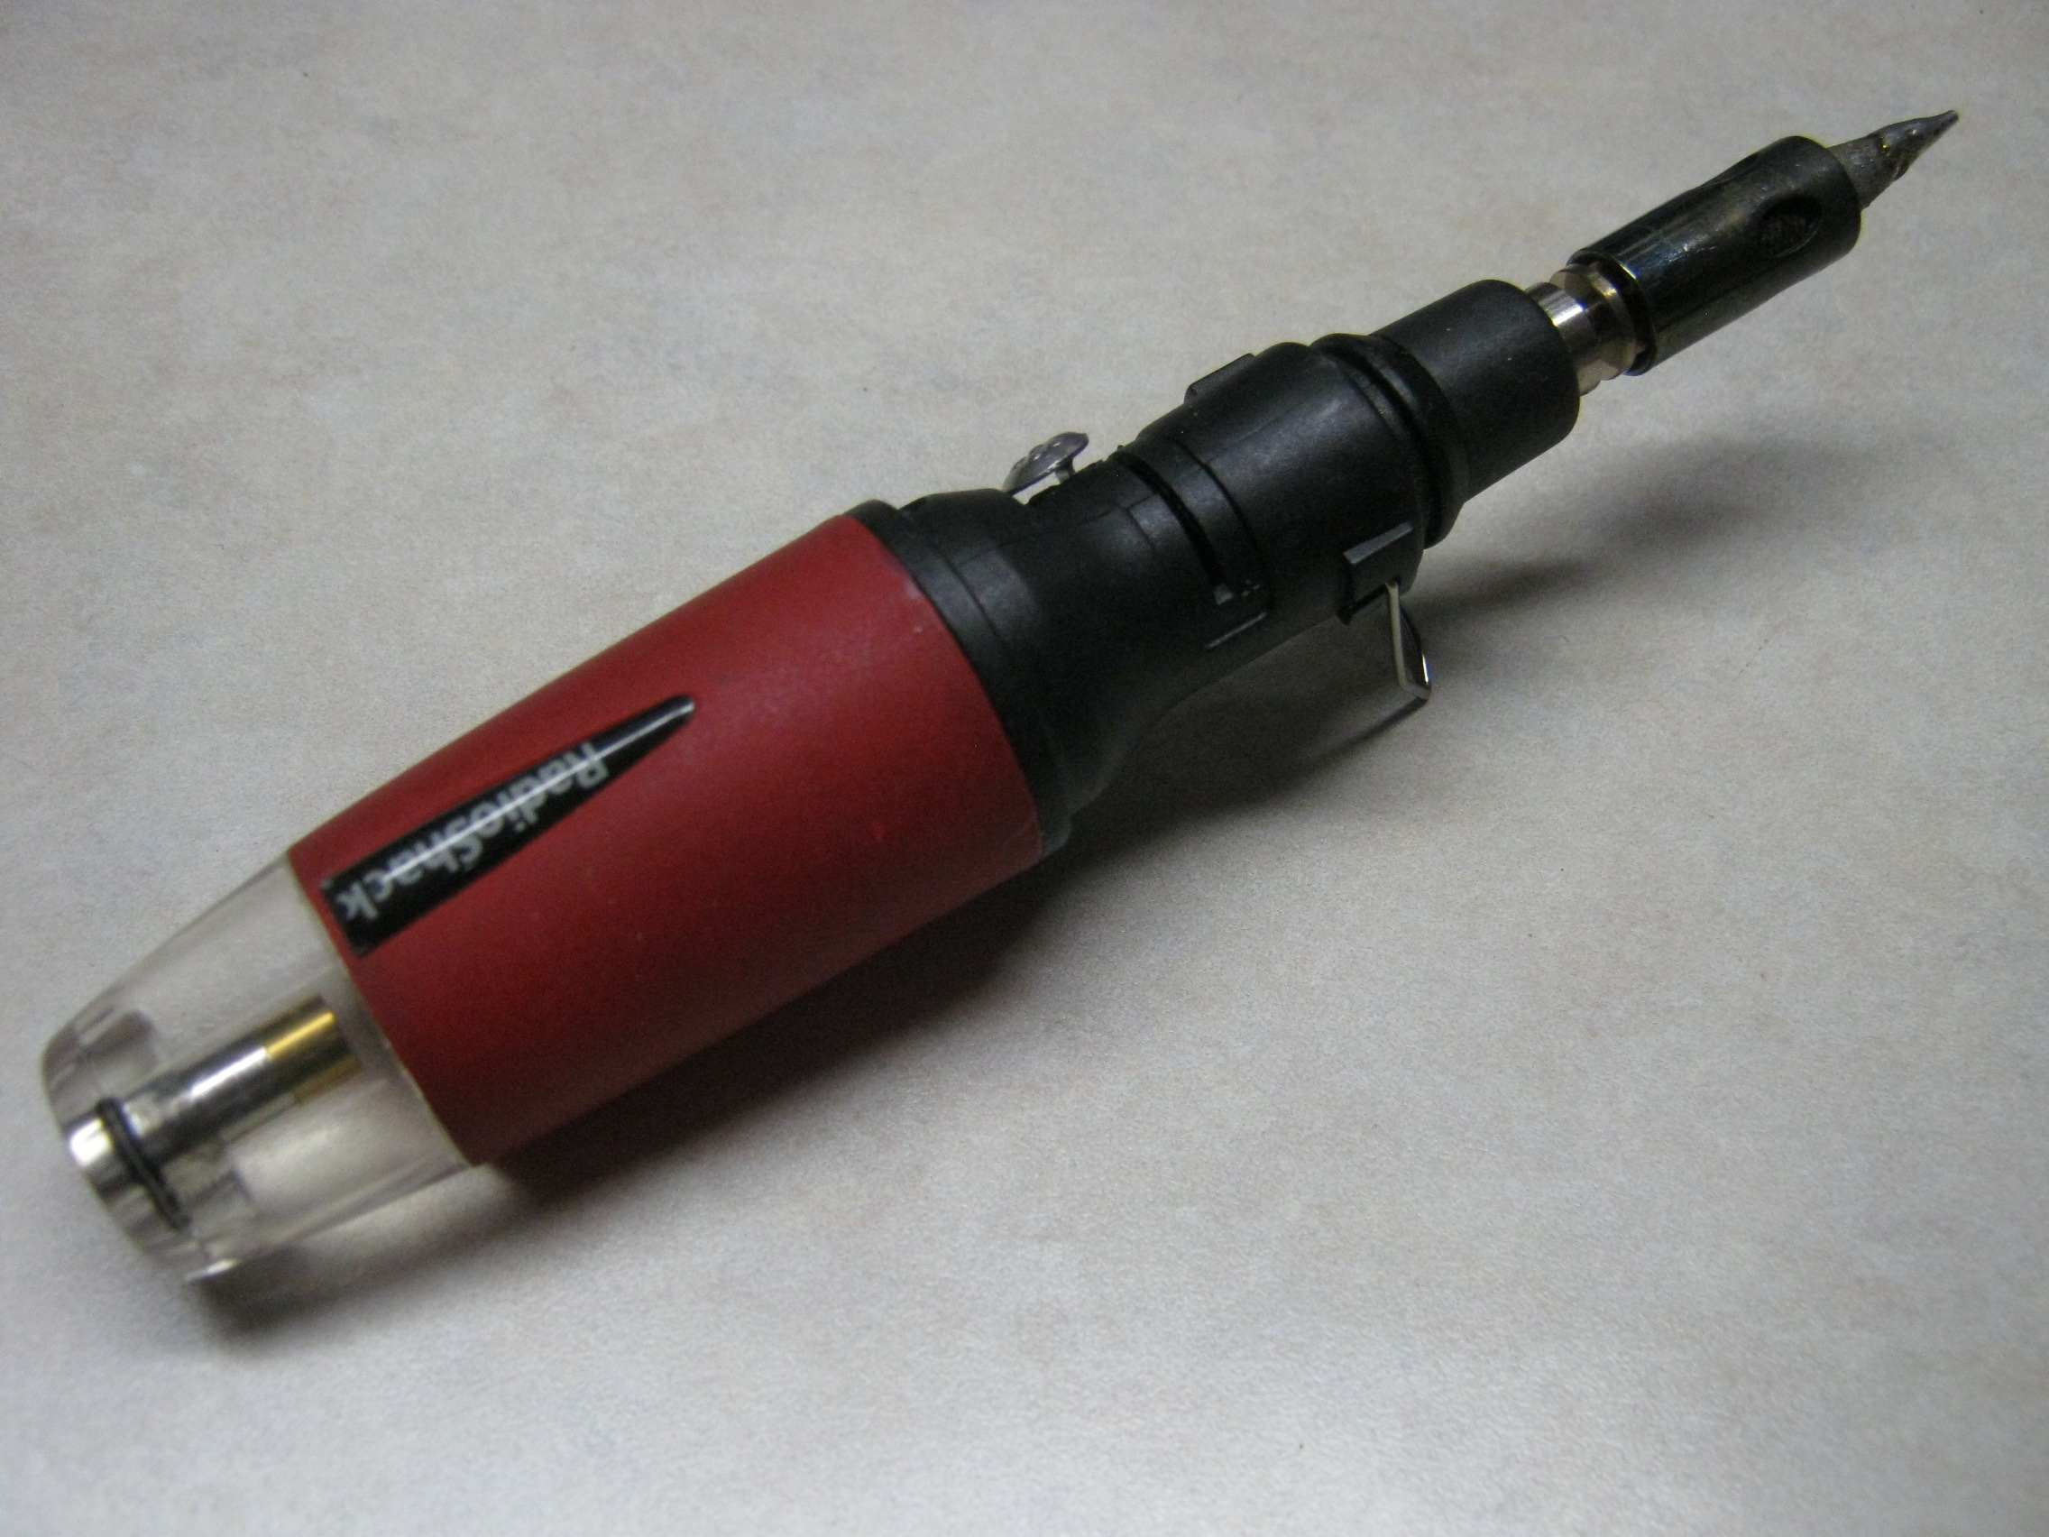
Here is another one of my favorite soldering irons. I love this iron and carry one in my portable QRP kit building toolbox. NOTE: TSA hates these! I've lost several to them...in both carry on and baggage. If they think that you have fueled it...it doesn't fly! This one is a Radio Shack version but they are available from other vendors too. Here is a link to one on Amazon:
https://www.amazon.com/Iso-Tip-7971-SolderPro-Butane-Soldering/dp/B001RIDT84/ref=sr_1_26?dchild=1&keywords=butane+soldering+iron&qid=1616296552&sr=8-26
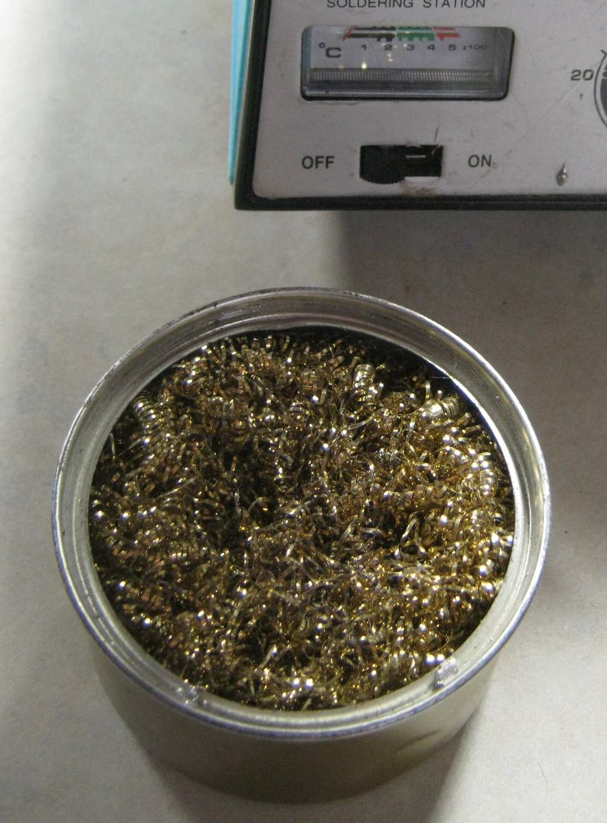
I don't use wet sponges for cleaning my iron's tip when building. Wet sponges turn water to steam when you swipe the tip clean which drops the tip's temperature. Brass shavings do a nice job of cleaning your soldering iron's tip without dropping the tip's temperature significantly. Both sponges and shavings do wear out so you will need to replace them periodically.

One last sensitive topic.....VISION!
You can't solder what you can't see. If you want to do a good job, you simply have to be able to read the markings on the part, see the color bands and watch the solder flow off the iron's tip as you solder.
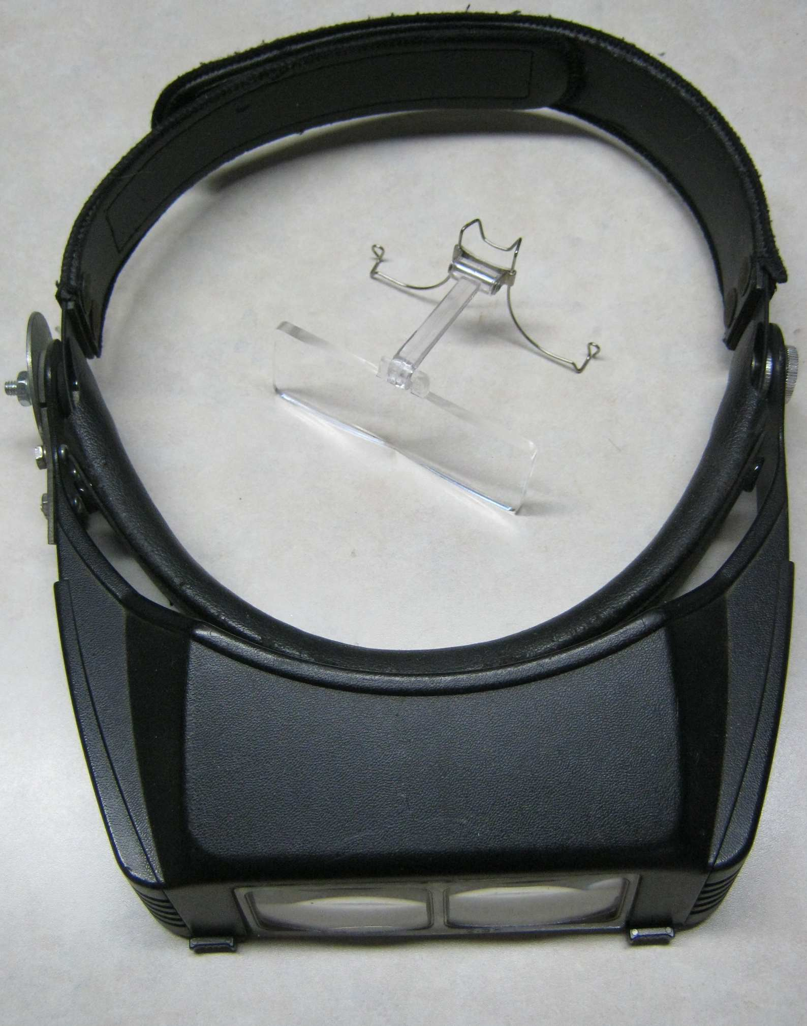
GOOD LIGHTING is a must so make sure your work area is lit well and you can discern the parts from each other. Some of those tiny caps have even tinier lettering.

EYESIGHT: My eyesight has been crap since I was a kid so I've been wearing glasses since I was 13 and 58 years later they are even crappier!. Make sure your prescription is up to date. I also have a decent visor magnifier. Again, you can get cheapies or spring for a decent pair. I still use a 'professional' pair that I bought over 30 years ago that I have had to repair several times.... A pair of optometrist's QRP compact magnifiers are shown in the center of my QRO pair.

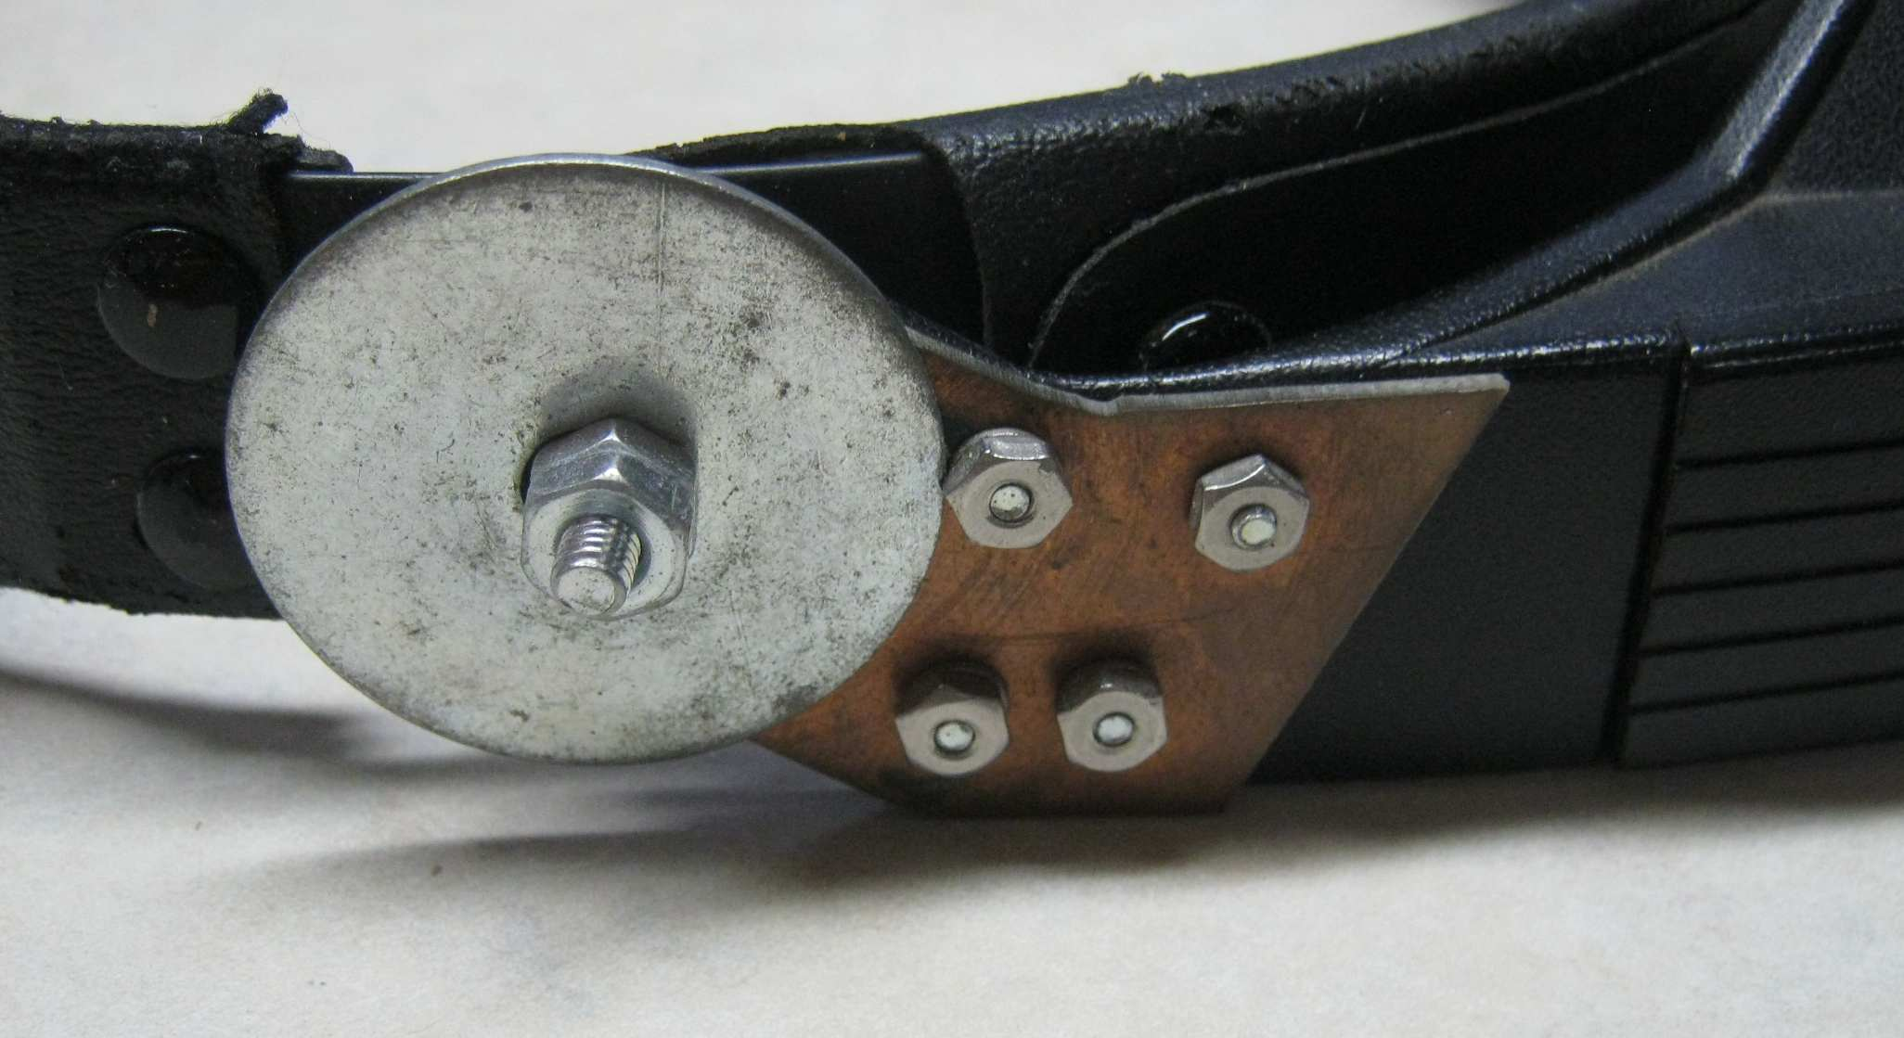
Fender washer & bolt for the hinge
and a piece of copper clad pcb stock
for a broken side piece and they
work as good as they did 30+ years
ago!
ENJOY YOUR KIT BUILDING
JOURNEY!
W1REX

